# Terms for Glossary

<https://confluence.hl7.org/display/GP/EP+Glossary>

# IEC 60601-2-18

201.3.202 CONFIGURATION FOR ENDOSCOPIC APPLICATION

combination of ENDOSCOPIC EQUIPMENT by means of INTERFACE CONDITIONS and/or INTERCONNECTION CONDITIONS with one or more of the following:

– ENERGIZED ENDOTHERAPY DEVICE(S)

– MEDICAL ELECTRICAL EQUIPMENT

– non-MEDICAL ELECTRICAL EQUIPMENT

– MEDICAL ELECTRICAL SYSTEM

NOTE Not all of the items in the CONFIGURATION FOR ENDOSCOPIC APPLICATION are included in the scope of this particular standard. See Figure AA.101 in Annex AA for a diagrammatic explanation.

201.3.210 INTERCONNECTION CONDITIONS

conditions that shall be fulfilled to achieve BASIC SAFETY when one or more ENERGIZED ENDOSCOPES are used simultaneously with one or more ENERGIZED ENDOTHERAPY DEVICES

201.3.211 INTERFACE CONDITIONS

conditions that shall be fulfilled to achieve BASIC SAFETY for any FUNCTIONAL CONNECTION

between ENDOSCOPIC EQUIPMENT and other ME EQUIPMENT or non-ME EQUIPMENT in the

CONFIGURATION FOR ENDOSCOPIC EQUIPMENT

# ISO/IEC 80601-2-13

201.3.209 anaesthetic workstation

system for administering inhalational anaesthesia that contains an anaesthetic gas delivery system, an anaesthetic breathing system and any required monitoring equipment, alarm systems, and protection devices

Note to entry: The anaesthetic workstation can also include, but is not limited to, one or more of the following: anaesthetic vapour delivery system, anaesthetic ventilator, anaesthetic gas scavenging system, and any associated, monitoring equipment, alarm systems and protection devices.

# IEC 80601-2-49

201.3.201 * MULTIFUNCTION PATIENT MONITOR

modular or pre-configured ME EQUIPMENT or MEDICAL ELECTRICAL SYSTEMS whose primary

intended function is monitoring of a single PATIENT, has more than one

PHYSIOLOGICAL MONITORING UNIT, either displays those information or distributes the

information for remote display, and either includes an ALARM SYSTEM or is a component of a

DISTRIBUTED ALARM SYSTEM

201.3.202 PHYSIOLOGICAL MONITORING UNIT

part of the MULTIFUNCTION PATIENT MONITOR whose purpose is to collect physiological signal(s)

from a single sensor type and to process it for monitoring

EXAMPLE 1 The pulse oximetry signal can provide information about oxygen saturation, pulse rate, perfusion, etc.

EXAMPLE 2 The signals from ECG ELECTRODES can provide information about ECG and thoracic respiration rate.

Note 1 to entry: Examples of physiological signals include (a) electrocardiography, (b) non-invasive blood pressure, (c) invasive blood pressure, (d) pulse oximetry, (e) temperature, (f) electroencephalography, (g) transcutaneous gas analysis, and (h) respiratory gas analysis. Each of these is a single physiological signal within the meaning of this definition.

Note 2 to entry: It is recognized that more than one variable or parameter may be derived from a single physiological signal.

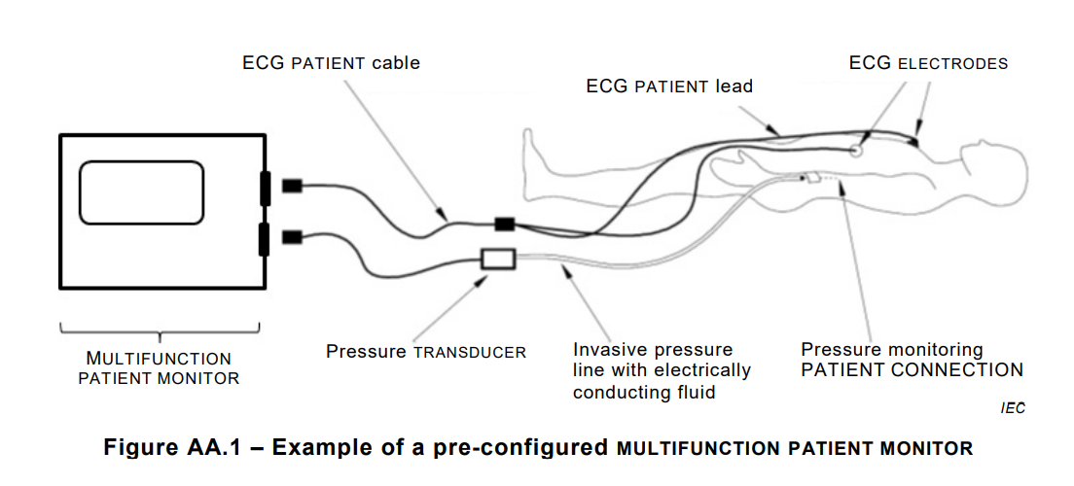

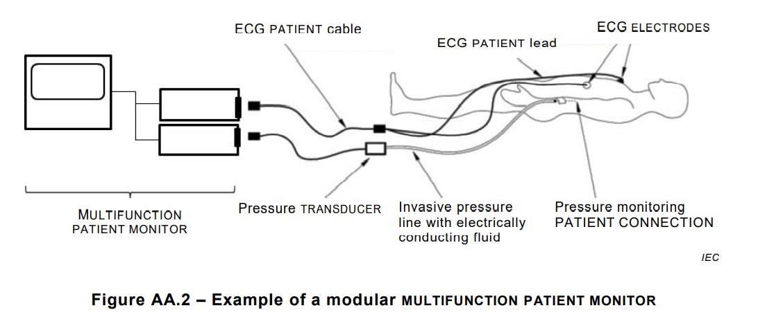

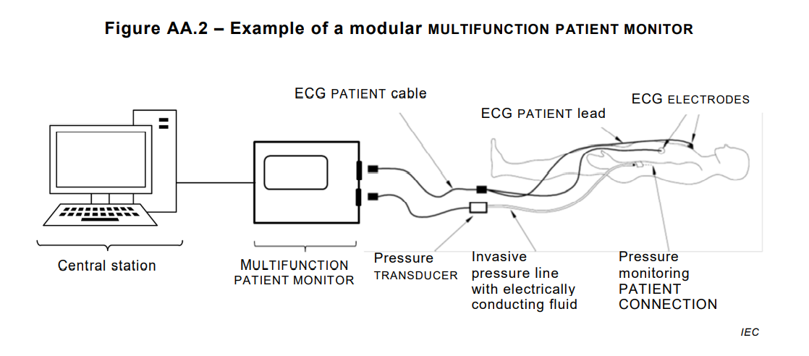

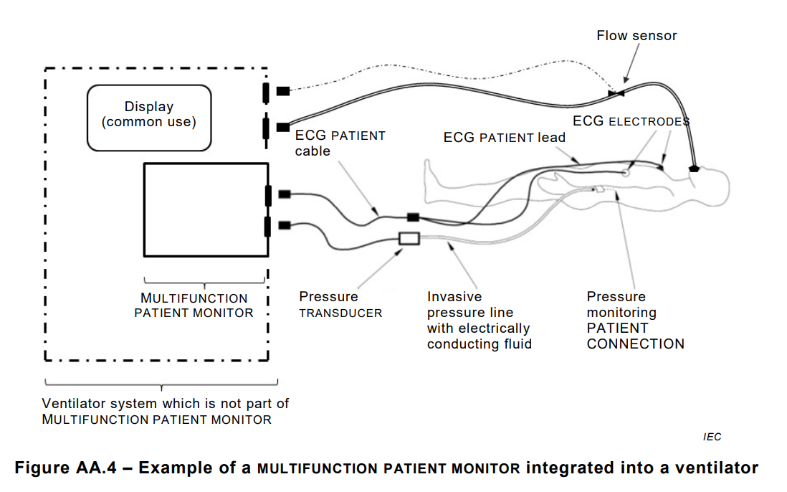

# ISO 81001-1

3.1.5 implementer

entity responsible for the clinical installation, workflow optimization, and training of health software (3.3.9) and health IT systems (3.3.8) in the clinical setting

Note 1 to entry: An implementer can be the manufacturer (3.1.7), the healthcare delivery organization (3.1.4), or a third party.

3.1.6 integrator

entity responsible for the incorporation of components (3.3.5) into the health IT infrastructure (3.3.7) used by the healthcare delivery organization (3.1.4), including technical installation, configuration, and data migration

3.1.12 system owner

senior executive accountable for ensuring the health IT system (3.3.8) being acquired and implemented will meet their organization’s (3.1.8) healthcare delivery services needs for its intended use (3.2.7)

3.2.4 configuration management

process (3.2.10) that ensures that configuration information of components (3.3.5) within the health IT infrastructure (3.3.7) are defined and maintained in an accurate and controlled manner, and provides a mechanism for identifying, controlling and tracking versions of the health IT infrastructure

Note 1 to entry: Adapted from ISO/IEC 20000-1:2018, 8.2.6.

3.3.1

accompanying information

accompanying document

accompanying documentation

information accompanying or marked on a health IT (3.3.6), product (3.3.15) or accessory for the user (3.1.14) or those accountable for the installation, use, processing, maintenance, decommissioning and disposal of the medical device (3.3.13) or accessory, particularly regarding safe use

3.3.7 health IT infrastructure

combined set of IT assets (3.3.2) available to the individual or organization (3.1.8) for developing, configuring, integrating, maintaining, and using IT services and supporting health, patient care and other organizational objectives

Note 1 to entry: Health IT infrastructure can include the following:

a) data and information;

b) health software (3.3.9);

c) medical devices (3.3.13);

d) IT hardware and services including mobile and desktop devices, IT networks (3.3.11), data centres, security (3.2.13), software development, IT operations and externally provided services such as internet, software as-a-service and cloud computing (3.3.3);

e) people, and their qualifications, skills and experience;

f) technical procedures and documentation to manage and support the health IT infrastructure;

g) health IT systems (3.3.8) that are configured and implemented to address organizational objectives by leveraging the above assets (3.3.2);

h) intangibles, such as reputation and image

3.3.8 health IT system

combination of interacting health IT (3.3.6) elements that is configured and implemented to support and enable an individual or organization’s (3.1.8) specific health objectives

Note 1 to entry: Such elements include health software (3.3.9), medical devices (3.3.13), IT hardware, interfaces, data, procedures and documentation

3.3.10 interoperability

ability of two or more systems (3.3.17) or components (3.3.5) to exchange information and to use the information that has been exchanged

3.4.1 assurance case

reasoned, auditable artefact created that supports the contention that its top-level claim (or set of claims), is satisfied, including systematic argumentation and its underlying evidence and explicit assumptions that support the claim(s)

Note 1 to entry: An assurance case contains the following and their relationships:

— one or more claims about properties;

— arguments that logically link the evidence and any assumptions to the claim(s);

— a body of evidence and possibly assumptions supporting these arguments for the claim(s); and

— justification of the choice of top-level claim and the method of reasoning.

# MDR (European Medical Device Regulation 2017/745/EU)

Article 2 Definitions

(25) ‘compatibility’ is the ability of a device, including software, when used together with one or more other devices in accordance with its intended purpose, to:

(a) perform without losing or compromising the ability to perform as intended, and/or

(b) integrate and/or operate without the need for modification or adaption of any part of the combined devices, and/or (c) be used together without conflict/interference or adverse reaction.

(26) ‘interoperability’ is the ability of two or more devices, including software, from the same manufacturer or from different manufacturers, to:

(a) exchange information and use the information that has been exchanged for the correct execution of a specified function without changing the content of the data, and/or

(b) communicate with each other, and/or

(c) work together as intended.

# AAMI White Paper AAMI MDI/2012-03-30 Medical device interoperability

accreditation: Specific organization's process of proving and demonstrating certification.

certification: The documented confirmation of certain characteristics of a component or system. For medical device interoperability Certification means an objective and repeatable verification through tests that a product meets a verified specific set of specifications and functions as expected for the intended use.

clinical scenario: Brief description of a clinical situation or event (ASTM, 2009).

compliance: In the IT sense, compliance is the state of being in accordance with established guidelines, specifications, or legislation. In a legal sense, it usually refers to organizational behavior in accordance with legislation such as HIPAA.

conformance: State or acts of adherence to a certain specification, standard, or guideline. Conformance does not necessarily imply the target specification, and desired functionality may work as expected until the system has been validated or that conformance has been independently verified.

device model: Abstract model that represents those capabilities and characteristics of a device that can be accessed and operated on externally in a particular context of use, typically including data types, relationships, and nomenclature used for input and output of observations and controls.

functional vs. non-functional capabilities: Terms describing the desired behavior, features, and capabilities of a system that are intended to address one or more use cases. Functional capabilities are expressed in the form “the system must do . . .” Non-functional capabilities are more closely associated with “how” the functions perform: “A system shall be . . .”

interoperability: Ability of medical devices, clinical systems, or their components to communicate in order to safely fulfill an intended purpose.

plug-and-play: Ability of medical devices, clinical systems, or their components to communicate in order to safely fulfill a-manufacturer’s intended purpose without custom integration or development.

profile: Specification showing in detail how to apply existing standards by restricting or constraining requirements in the referenced standards.

quality of service: Set of non-functional properties of a system that define quantitative constraints on how well a service is delivered.

standard: Document established by consensus and approved by a recognized body that provides for common and repeated use, rules, guidelines, or characteristics for activities or their results. A standard is aimed at achieving the optimum degree of order in a given context. Standards are

• shaped by consensus;  
• typically developed in an open and transparent process, with representation of all interested and engaged parties; and  
• primarily market-driven (industry-sponsored).

use case: Description of a set of sequences of actions, including variants, that a system performs that yields an observable result of value to achieve a clinical or technical goal. Use cases are characterized by human interaction and workflow considerations.

validation: Confirmation by examination and provision of objective evidence that the particular requirements for a specific intended use can be consistently fulfilled (CFR, 2011)

UL 2800-1 (draft)

4.8 ARCHITECTURE VIEW – Artifact within the INTEROPERABILITY ARCHITECTURE expressing the architecture from the perspective of specific set of concerns.

4.9 ARCHITECTURE VIEWPOINT – Constraints establishing the conventions for the construction, interpretation, and use of an ARCHITECTURE VIEW to frame a specific set of concerns.

4.10 ASSURANCE – Grounds for justified confidence that a claim has been or will be achieved.

4.21 DISCLOSURE – Planned and managed release of information between the ORGANIZATION originating the INTEROPERABLE ITEM and stakeholder ORGANIZATIONs to support the safe and secure use of the INTEROPERABLE ITEM in its DEVELOPMENT CONTEXT OF USE or DEPLOYMENT CONTEXT OF USE.

4.22 EFFECTIVENESS – Ability to produce the intended result for the PATIENT and the RESPONSIBLE ORGANIZATION. Reasonable assurance that a device is successful in producing a desired or intended result when it can be determined, based upon valid scientific evidence, that in a significant portion of the target population, the use of the device for its intended uses and conditions of use, when accompanied by adequate directions for use and warnings against unsafe use, will provide clinically significant results.

4.28 FUNCTIONAL SAFETY CONCEPT – Design of functional safety including independence aspects, allocation to ITEMS within the ARCHITECTURE, RISK CONTROLs, and their interaction necessary to achieve SSOs.

4.38 INTERACTION – An action between an INTEROPERABLE ITEM and its context taking place over one of the INTEROPERABLE ITEM's interfaces.

4.39 INTERACTION BEHAVIORAL SPECIFICATION – Constraints on the interactions between an INTEROPERABLE ITEM and its context over its INTERFACEs specified in terms of INTERFACE CONTRACTs.

4.43 INTERFACE CONTRACT – Behavioral constraints on the INTERACTIONs between an INTEROPERABLE ITEM and its context over one of its INTEROPERABILITY INTERFACEs.

4.44 INTERFACE SPECIFICATION – Collection of INTERACTION SPECIFICATIONs, associated INTERFACE CONTRACTs, and engineering and technology aspects of the interface realization.

4.45 INTEROPERABILITY ARCHITECTURE – Constraints and rules determining the ORGANIZATION of a set of INTEROPERABLE ITEMs, their designed interoperable INTERACTIONs with each other, and their intended INTERACTIONs with environment. The INTEROPERABILITY ARCHITECTURE provides a decomposition at the granularity at which INTEROPERABLE ITEMs may be exchanged and reused according to their designed interoperability.

4.46 INTEROPERABILITY ARCHITECTURE CONFIGURATION – Specific restriction of one or more INTEROPERABILITY VARIABILITIES of an INTEROPERABILITY ARCHITECTURE.

4.48 INTEROPERABILITY BINDINGS – Planned association of two or more INTEROPERABLE ITEMs over designated interoperability INTERFACEs of the INTEROPERABLE ITEMs.

4.49 INTEROPERABILITY ECOSYSTEM – Stakeholders whose products and services enable interoperability.

4.50 INTEROPERABILITY FILE – One or more information repositories either containing or referencing records generated to demonstrate compliance to the requirements of this Standard.

4.51 INTEROPERABILITY FRAMEWORK – Consists of a managed collection of interoperability assets including:

a) Items designed to be integrated in different configurations in conformance with a INTEROPERABILITY ARCHITECTURE;

b) Processes conforming to life-cycle OBJECTIVEs of this Standard for coordinating life-cycle activities across the framework items to increase effective and trustworthy reuse of items and associated specification, RISK MANAGEMENT, and assurance results; and

c) Assets, shared across the development of the framework items, for supporting interoperability-related aspects of development and assurance.

4.52 INTEROPERABILITY INTERFACE – An engineered mechanism for information exchange that provides all or part of a realization of an interoperability INTERACTION POINT.

4.55 INTEROPERABLE APPLICATION SPECIFICATION – A summary of the important characteristics related to the use of the INTEROPERABLE MEDICAL PRODUCT within stated INTEROPERABILITY SCENARIO SPECIFICATIONs.

4.56 INTEROPERABLE ENVIRONMENT – The managed collection of interoperable products and associated services that can be integrated in one or more configurations to enable interoperable use of a specific INTEROPERABLE MEDICAL PRODUCT.

4.60 INTEROPERABLE MEDICAL PRODUCT – Output that is intended for, or required by, a customer, for supporting the development and deployment of an INTEROPERABLE ITEM for medical purpose.

4.64 IT-NETWORK [INFORMATION TECHNOLOGY NETWORK] – A system or systems composed of communicating nodes and transmission links to provide physically linked or wireless transmission between two or more specified communication nodes.

4.87 PROVENANCE – A record of the original source and chain of possession of data – combination of AUTHENTICITY, INTEGRITY, and no-repudiation for every entity that has processed the data – a chain of AUTHENTICATION OF INFORMATION.

4.88 REFERENCE ARCHITECTURE – An INTEROPERABILITY ARCHITECTURE for an INTEROPERABILITY FRAMEWORK that serves a schema and establishes constraints on INTEROPERABLE ITEM and INTEROPERABLE MEDICAL SYSTEM instances that are compliant with the INTEROPERABILITY FRAMEWORK.

4.89 RELEASE CRITERIA – Conditions and traceability relationships on the INTEROPERABLE ITEM INTEROPERABILITY SPECIFICATION, INTEROPERABLE ITEM realization and associated work products and DISCLOSUREs that are to be achieved and substantiated with OBJECTIVE EVIDENCE before the INTEROPERABLE ITEM is released.

4.90 RESPONSIBILITY AGREEMENT – One or more documents that together fully define the responsibilities of all relevant stakeholders.

4.98 TECHNICAL SAFETY CONCEPT – Design of the realization of the FUNCTIONAL SAFETY CONCEPT in terms of the INTEROPERABILITY ARCHITECTURE and technical requirements used in the realization of the INTEROPERABLE ITEM.

Adapted by UL from ISO 26262-1:2018 with permission of the American National Standards Institute (ANSI) on behalf of the International Electrotechnical Commission. All rights reserved.

4.99 VALIDATION – Confirmation, through the provision of OBJECTIVE EVIDENCE, that the INTEROPERABLE ITEM is fit for purpose as expressed in the INTEROPERABLE USE SPECIFICATION and INTEROPERABLE APPLICATION SPECIFICATION.

4.100 VERIFICATION – Confirmation, through the provision of OBJECTIVE EVIDENCE, that specified requirements have been fulfilled.

# Design Considerations and Premarket Submission Recommendations for Interoperable Medical Devices Guidance for Industry and Food and Drug Administration Staff

Electronic interface:

For purposes of this guidance, the electronic interface is the medium by which systems interact and/or communicate with each other thereby allowing the exchange of information between systems. It includes both the type of connection (e.g. USB port, wireless connection) and the information content. It is a medium by which a medical device exchanges and uses information with other equipment or other medical devices.

Interoperable medical devices:

For purposes of this guidance, interoperable medical devices are devices as defined in section 201(h) of the Federal Food, Drug, and Cosmetic Act (FD&C Act) that have the ability to exchange and use information through an electronic interface with another medical/nonmedical product, system, or device. Interoperable medical devices can be involved in simple unidirectional transmission of data to another device or product or in more complex interactions, such as exerting command and control over one or more medical devices. Interoperable medical devices can also be part of a complex system containing multiple medical devices.